Proposition de corrigé de la version d'Edith Wharton

Elle sentit qu'on lui touchait le bras et croisa / rencontra le regard désolé de Miss Kilroy. «Miss Bart, je pense / crois que vous êtes capable de coudre ces sequins aussi bien que moi quand vous vous sentez dans votre assiette. Miss Haines ne s'est pas bien conduit envers vous / n'a pas été juste avec vous.»

Lily rougit devant cette avance inattendue / Le rouge monta aux joues de Lily face à cette avance inattendue : cela faisait longtemps qu'on n'avait plus posé sur elle un regard empli de vraie gentillesse, Gerty exceptée.

«- Oh, merci: je ne suis pas très en forme mais Miss Haines avait raison. Je SUIS / suis très maladroite.

* Oh mais / Eh bien / Bon mais c'est un travail éprouvant / ingrat quand on mal à la tête.» Miss Kilroy s'arrêta, hésitante. «Vous devriez rentrer direct chez vous et vous allonger. Z'avez déjà essayé l'orangine?
* Merci. Lily lui tendit la main. C'est très aimable à vous - je vais rentrer chez moi.
* Merci, répéta-t-elle en s'éloignant.

Elle mit cap à l'ouest dans le sinistre / crépuscule de mars, en direction de la rue où se trouvait sa pension de famille / son foyer de jeunes travailleurs. Elle avait refusé l'offre d'hospitalité que lui avait faite Gerty de manière catégorique. Quelque chose du rejet farouche que manifestait sa mère à l'encontre de l'observation et de la compassion commençait à se développer chez elle, et la promiscuité liée à un petit appartement et une intimité étouffante lui semblaient, dans l'ensemble, moins supportables que la solitude d'une chambre (dans un foyer), dans une maison où ses allées et venues pouvaient passer inaperçues aux yeux des autres travailleurs. Pendant un certain temps, ce désir d'intimité et d'indépendance l'avait soutenue; mais à présent, peut-être en raison de sa fatigue physique croissante, de la lassitude apportée par les heures d'enfermement auxquelles elle n'était pas habituée, elle commençait à ressentir de manière aigüe la laideur et le manque de confort de son environnement. Une fois la tâche de la journée accomplie, elle redoutait le retour dans sa chambre étroite au papier peint taché et à la peinture vieillote / défraîchie; et elle détestait chaque pas qui l'y menait le long d'une rue de New York qui en était aux dernières étapes de son déclin dégradant la transformant de rue à la mode en artère vouée au commerce. / *à travers l'avilissement d'une rue jadis à la mode et qui achevait d'être abandonnée au commerce. (Traduction de Charles du Bos, 1905)*

* *Edith Wharton*
* *Important narratology notions*
* *Historical background*
* *Commentary outline*

*Some background on Edith Wharton (1862-1937):*

Born in a very wealthy American family that had made its fortune in banking & shipping, she started to write as a young girl but only published her first novel in 1898.

She wrote about the realities of upper society New York at the time of her parents or of her own childhood, that is to say a time that was past.

She married Teddy Wharton in 1885, who came from the same background, but they had absolutely no interests in common. They were eventually divorced thirty years later.

She managed to blossom intellectually by removing from America. She started spending more and more time in France, near Paris, in St Brice-sous-Forêt., close to L'Isle-Adam and Auvers-sur-Oise.

During WWI, she was in Paris and was active in helping the wounded.

Her best known works:

*The House of Mirth* (1905)

*Ethan Frome* (1911)

*The Reef* (1912)

*The Custom of the Country* (1913)

*The Age of Innocence* (1920)

*Old New York* (short stories; 1924)

She also wrote countless short stories, including some about WWI.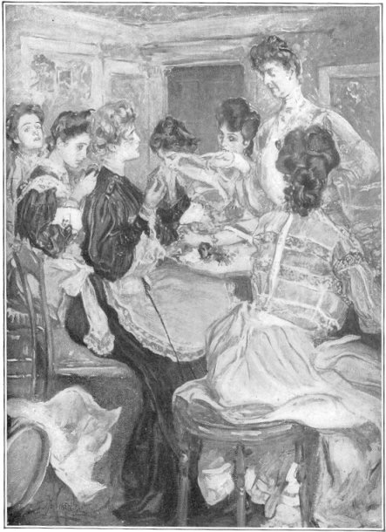

*The House of Mirth* was a *New York Times* best-seller when it first came out and this illustration is reproduced from the original edition published in October 1905. (As an indication, the novel sold over 140,000 copies in just over two months, surpassing *Jungle*, Upton Sinclair's best-selling exposé of the Chicago meat-packing industry.) Wharton, by the way, regretted authorizing an illustrated edition…

**"Look at those spangles, Miss Bart, --every one of 'em sewed on crooked." (opposite p. 456), from the October 1905 Charles Scribner's Son's edition, with illustrations by A. B. Wenzell.**

Internal focalization vs stream of consciousness:

First, a quick reminder: the notions are by and large the same in French or English; what changes is the vocabulary.

In English lit. crit., Henry James was the first to formalize the notions which Genette later refined in his narratology theory. The difficulties of course tend to arise when you get confused by the slight shifts in terminology…

In English, we like to speak of "**point of view**": it can be **omniscient** (the narrator knows everything) or **limited**.

The omniscient narrator can be *intrusive* (he not only reports but also comments on the actions of the characters: George Eliot comes to mind…). The opposite is the *uninintrusive* narrator (Hemingway's story, *The Killers*, is an extreme example.)

Genette's distinction between the *focus of narration* (who tells the story) and the *focus of character* (who perceives what is narrated in one or another section of the story) sparked the critical use of **external** vs **internal focalization**.

Here, l. 24-27 can be confusing but *The House of Mirth* is a classic 3rd person omniscient narrative and it's a simple case of internal focalization with Lily as the focalizer. L. 28-9 show the narrative resume its normal pace.

In the **limited point of view**, the narrator stays inside the confines of what is thought, perceived etc by a single character. Henry James, who used the technique a lot, spoke of this character as the *centre of consciousness*. Pushed to its limits, it gave rise to the *stream-of-consciousness* narration, in which we are shown outside perceptions only as they touch upon the continuous current of thought, memory, feelings etc which constitute a character's total awareness.

Here's an example from the beginning of *Mrs Dalloway* (a chance encounter has led Clarissa Dalloway to reminisce about the young men who courted her):

So she would still find herself arguing in St. James’s Park, still making out that she had been right — and she had too — not to marry him. For in marriage a little licence, a little independence there must be between people living together day in day out in the same house; which Richard gave her, and she him. (Where was he this morning for instance? Some committee, she never asked what.) But with Peter everything had to be shared; everything gone into. And it was intolerable, and when it came to that scene in the little garden by the fountain, she had to break with him or they would have been destroyed, both of them ruined, she was convinced; though she had borne about with her for years like an arrow sticking in her heart the grief, the anguish; and then the horror of the moment when some one told her at a concert that he had married a woman met on the boat going to India! Never should she forget all that! Cold, heartless, a prude, he called her. Never could she understand how he cared. But those Indian women did presumably — silly, pretty, flimsy nincompoops. And she wasted her pity. For he was quite happy, he assured her — perfectly happy, though he had never done a thing that they talked of; his whole life had been a failure. It made her angry still.

She had reached the Park gates. She stood for a moment, looking at the omnibuses in Piccadilly.

References : M. H. Abrams, *A Glossary of Literary Terms*, 9th edition, 2009

David Lodge, *The Art of Fiction*, ch. 2 & 10, London, 1992

The Industrial Revolution and the Industrial Age

The industrial revolution began in England in the decade 1765 - 1775 (roughly) with the development of coal mining and its transportation on canals crisscrossing the country, the invention of the spinning jenny in 1765, starting the seemingly neverending process of mechanization in the textile industry, and ten years later the invention of James Watt's steam engine.

By the 1820s, mechanization was all but complete in the textile industry. The period 1820-1900 saw a mind-boggling succession of inventions or applications (the electric motor, the railway, the telegraph, photography, concrete, steel, the telephone, the phonograph, the electric light bulb, the internal-combustion engine, the airplane and the automobile). As the century progresses, there's a shift in the place where those inventions are made, away from England and more and more towards the U.S.

The U.S. was about 30 years behind England, but by dint of technology transfer (or intellectual property theft…) managed to catch up quite fast, spurred on by the immense needs prompted by the country's settlement, its growing urbanization, and the inflow of immigrants. In other words, in the context of *The House of Mirth*, mass industrialization was becoming the norm (Ford began mass-producing its T-model in 1908) but Mme Régina's work-room was definitely not a factory but rather an up-market sweatshop.

*What did Lily Bart do and earn?*

Seamstresses, dressmakers and milliners formed the great mass of female workers in 19th century urban America. Their situations were very different though. At the bottom of the ladder were the seamstresses: working from home, they were paid by the piece, but very often could barely make ends meet and had to rely on charity even when working 16 hours a day. Dressmakers and milliners could command much higher wages, a necessity since most of them were the sole wage-earners in their household as few of them were married. But let's not kid ourselves: even a comparatively well-paid female worker would always have earned much less than her male counterpart.

*Further References :*

<https://tenement.org/encyclopedia/garment_dress.htm>

<http://americanhistory.si.edu/sweatshops/history/seamstress.htm>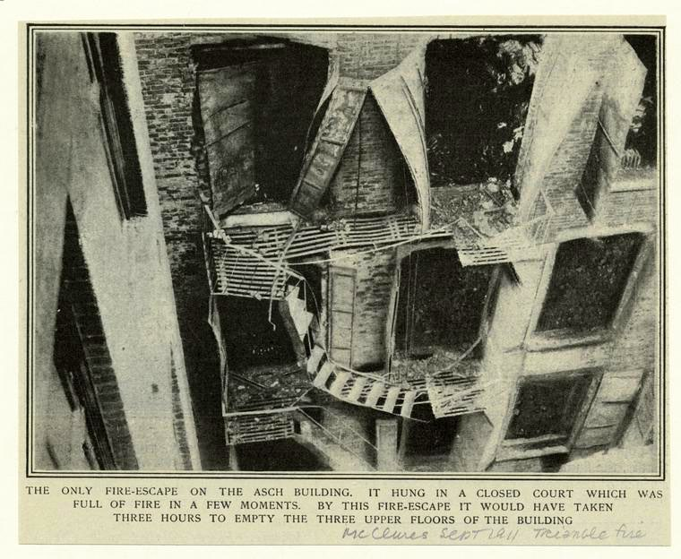

Fire Escape Of Asch Building After The Triangle Fire, New York City, 1911. Image ID: 804790

"One hundred and forty-six workers died, mostly young women from immigrant families. The fire was deadly because of the height of the building, the amount of fabric and flammable material inside, the lack of proper fire escapes, and exits that were locked to prevent workers from taking breaks. Many fell or jumped to their deaths. The tragedy brought greater awareness to sweatshop conditions, which led to widespread changes in labor practices and the movement towards legal protection of workers' rights."

Source: <http://www.nypl.org/blog/2011/03/25/triangle-shirtwaist-factory-fire>

Commentary Outline

Thesis: What can first be read as an accurate exposé of the working female condition in the Gilded Age (1880s-1900s) is actually a more complex specular presentation of the fate of women at the time, one that reaches its acme in the poetic celebration of the Baudelairian figure of "la Passante" in its closing lines.

1. *A day in the life of a New York working-girl*
   1. Starting *in medias res* with the description of the work-place, the narrative follows Lily Bart from what she actually does for a living to where this occupation condemns her to live, thus pencilling in a quick sketch of the lives in the clothing industry. Sensory notations prevail, (l. 1, 2, 7; 62, 63) which is in keeping with the internal focalization on Lily in those descriptive passages. One may comment on the nature of the sensations in question, whose iteration throughout the passage (noises and stifling atmosphere) are a marker of the physical constraints imposed by work on the labourer (see also l. 59). One is also struck by the fact that Lily's alienation has taken such proportions that she makes Miss Haines's criticisms her own (l. 24-25).
   2. The choice of words also reflects the hierarchies used to keep the worker in line: from the "frame" (l.1) over which, as a mere "raw beginner"(l.32), an "apprentice" (l. 31) she has to bend to the "forewoman" (l. 24) berating her and ultimately Mme Regina, presiding over her establishment like the queen bee the onomastics suggest, everybody fits into her slot, must keep in line, even when unfairnesses arise (l. 42-46). Wharton had read Frazier's *Golden Bough* and applied some of his anthropological analyses in her studies of New York Society. As a microcosm in its own right, Mme Regina's workroom is depicted as a beehive of course, but also as a space devoid of open solidarity, since Miss Kilroy's smile is, per force, "suppressed" (l. 28). The intrusive narrator's remarks at l. 12-13, 18-19, 32-33 and 35 underscore the crass materialism the girls share with all other Americans (l. 18) and a certain form of social darwinism at work.
   3. The passage also reflects an underlying reality of the working-world at the time. Mme Regina's "temple of art" is quite removed from the seedier sweatshops then springing across all the Lower East Side, but even though the work is still done by hand (l. 24), it is quite remarkable that Wharton should have used the noun "toilers" to describe the working girls, since it is derived from the Latin *tudicula* (by way of the Anglo-Norman *toiler*, meaning to stir), which was a machine for bruising olives. In other words, the anonymous workers of Mme Regina's, who remain nameless for the greater part and are lumped together in plural pronouns and nouns, are already machines, mere cogs in a greater insensitive whole, in this "underworld" D.H. Lawrence would depict so graphically a few years later in the pages of *Women in Love*. The boarding-house described l. 56-7 matches, by its anonymity and its ugliness (the narrow rooms emulating the closeness of the workshop), this new modern working-world whose structures take so much from the animal world.
2. *A reflection in a mirror*
   1. The focalization on Lily Bart foregrounds her sensory experience of the workplace, an experience brought about the "sleepless night" and which bears all the signs of a nightmarish vision, since we're told that "the chatter of her companion had the incoherence of a dream". The metaphor is carried on l. 7-8, since the process of recognition mimicks the pattern of images in dreams, and the polyptoton on "strange" reinforces the quasi uncanny dimension of Lily's "experience". (Can be developed by showing the contrast with the actual bits of dialogue, mundane to the point of nothingness.)
   2. In fact, the Gothic topoi of "fragmentary and distorted image[s]", of the isolated house of shame and horror, of the formidable and frightening gaoler figure (Miss Haines, whose very name evokes heinous deeds, or Mme Regina, which hints at domination) all contribute to make of Lily the perfect 'centre of consciousness', to use James's phrase, in which both upper-class New York and working-class New York meet in the specular vision evoked l. 10 and from which they each recoil in horror.
      1. The girls first, because their "definite knowledge of (…) the social system" (l. 15) is the sign of their desire for a place in it, however humble. Their very American preoccupation with "success", with money (wonderfully described l. 19 by Wharton as " the gross tangible image of material achievement") does not necessarily imply, however, that they wish for Lily's former lifestyle, since it involves a fair amount of "vanity and self-indulgence" that is not in keeping with the "contemptuous freedom" they relish. (can be further developed with all the characteristics of the girls + Miss Kilroy : kindness, awkwardness, speech register)
      2. The metaphor of Lily as a fallen star is used very cunningly by Wharton and can be read in several ways (Fallen angel / pre- vs post-lapsarian universe etc…), but we shall focus on its ironical treatment. From the very beginning of the passage, Lily is the butt of narrative irony, starting of course with her first name, Lily, which hints at the idleness (cf Matthew, 6, 28 : "And why are you worried about clothing? Observe how the lilies of the field grow; they do not toil nor do they spin,", New American Version) she can no longer sustain. Wharton's irony is also expressed in the means she uses to reflect back Lily's experience. The crest-fallen Lily is constantly reminded of her new lowly position either by "the buzz of talk which rose and fell", the very movement of sound literally smothering her and pinning her further to the bottom, as l. 4 also illustrates, or by the contrast between the "underworld" and the "headgear" manufactured there. Likewise, the antithesis between Lily's erstwhile visits of the Girls' Club, when she presumably floated at a "happy altitude" (l. 40) and her current situation, "level with" (41) the workers, or rather "'gone under'" (L18), is underscored with great irony, the narrative voice mocking both her presumption ("her grace and beneficence") and the disillusion felt by both parties ("the point of view was less interesting", l. 40-41).
3. *Lily, passing between both worlds*

Wharton often wrote about the way in which a new social class swept away the old order (which, in the New York world she described, seemed to happen with great frequency), but *The House of Mirth* is probably the novel in which the journeys up or down of her characters take on their most poignant overtone, and this is due to the way in which Lily Bart's character is depicted in the last chapters of the novel, including this passage.

* 1. A state of flux : The whole page seems to be adrift on a current of strong emotions, swirling and eddying to the rhythm of the "buzz of talk which rose and fell", which "flowed on and on". There is of course Lily's exhaustion, shame and probable despair, but what is most paradoxical is the way in which the narrative keeps moving her along her day and the streets of New York even though her very name implies a certain immobility. To some extent, Lily, like her namesake, is adrift. Her going "under" implies that she has slipped her moorings and cannot rest until she reaches the bottom, like some parts of New York left behind by the constant northward expansion of the city in the 19th century, which the last line of the passage makes quite clear.
  2. Une passante[1] : the assimilation of Lily to the cityscape surrounding her is by no means original, inasmuch as Baudelaire, with his poem, 'A une Passante' (1855), had codified the emergence of this (then) new figure, the woman in the crowd:

La rue assourdissante autour de moi hurlait.

Longue, mince, en grand deuil, douleur majestueuse,

Une femme passa, d'une main fastueuse

Soulevant, balançant le feston et l'ourlet;

Agile et noble, avec sa jambe de statue.

Moi, je buvais, crispé comme un extravagant,

Dans son oeil, ciel livide où germe l'ouragan,

La douceur qui fascine et le plaisir qui tue.

Literary topos it may be, but late 19th century literature was full of these women gliding through the streets, slipping unnoticed down side alleys (Mina when she first appears in *Daniel Deronda* by George Eliot, Maggie in the eponymous novel by Stephen Crane). What makes Lily's case especially poignant is the way in which she desperately clings to some shred of dignity in the midst of her downward spiral. The ironic narrator drops its acidic tone when he charts the progress of Lily's slow self-effacing from life, noting how she was "listening absently" (l. 1), that is not listening to "meaningless sound" (l. 6), which is probably just as well since she no longer has a common language with her co-workers (and fellow Americans…), l. 20-21. Her inner isolation takes on a more concrete dimension once work is over, since we are told that "She did not care…promiscuous." (l. 35-38). Like her mother (l. 54), Lily shrinks from contact, to the point of deliberately reducing her living space to the utmost, the "narrow room" reflecting the square-footage she still allows herself. Yet at the same time this is but a simulacrum of life as the final sentence of the passage underscores quite clearly, since its periodic structure ends with an amplification resoundingly mingling Latin words-degradation, decline, commerce- and Anglo-Saxon ones-dreaded, shabby, fashion- leaving the reader in little doubt as to Lily's ultimate fate (where can she go since she hates her room as much as the street that leads to it?).

1. I am indebted to Professor Nathalie Cochoy for first drawing my attention to this notion with her wonderful study : Cochoy Nathalie, *Passante à New York*. Bordeaux, Presses Universitaires de Bordeaux, 2009